RHEK GLOBAL

logo : flip slow animation on going

Book a Meeting
Button Action: When visitors click the button, they will be redirected to our Calendly or meeting booking page, where they can conveniently select their preferred meeting date and time.

Main Nav Bar
- Home
- About us
- Services
  - Janitorial Lead Generation
  - Sales Development & Appointment Setting
  - Social Media Advertising
  - Web Design & Development
  - Graphic Design
  - Video Editing & Production
  - Email Marketing
  - Virtual Assistant & Administrative Support
- Team
- Careers
- Contact

1. Company Profile
1.1 Business Information
• Company / Brand Name: RHEK GLOBAL
• Primary Headline / Value Proposition: Empowering businesses through intelligent digital, operational and outsourcing solutions.

2. Services
- Janitorial Lead Generation
- 100% Exclusive & Qualified Leads
- Professional B2B Cold Calling
- Verified Business Contact Information
- Appointments with Real Decision-Makers
- Confirmed Appointment Date & Time
- Specific Cleaning Needs & Service Requirements
2. Sales Development & Appointment Setting
- B2B & B2C Cold Calling
- Outbound Sales Development
- Inbound Call Handling
- Qualified Appointment Setting
- Lead Qualification & Follow-ups
- Telemarketing Campaign Management
3. Social Media Advertising
- Facebook & Instagram Ads
- LinkedIn Advertising
- Social Media Campaign Management
- Audience Targeting & Retargeting
- Paid Social Media Campaigns
- Ad Performance Optimization
4. Web Design & Development
- Premium 3D Website Design & Development
- Custom Corporate & Business Website Design
- Modern UI/UX Design & Interactive Experiences
- E-commerce & Shopify Store Development
- WordPress & Custom Web Application Development
- 3D Animation & Interactive Web Experiences
- Responsive Design, SEO & Performance Optimization
5. Graphic Design
- Logo & Brand Identity Design
- Social Media Post Design
- Marketing & Advertising Creatives
- Brochure & Flyer Design
- Business Presentation Design
- Banner & Promotional Design
6. Video Editing & Production
- Corporate & Promotional Video Editing
- Social Media Video Editing
- YouTube Video Editing
- Reels & Shorts Production
- Motion Graphics & Animation
- Video Ads & Commercial Editing
7. Email Marketing
- Email Campaign Management
- B2B Cold Email Outreach
- Email Automation
- Email List Building & Segmentation
- Email Newsletter Design
- Campaign Performance Tracking
8. Virtual Assistant & Administrative Support
- Executive & Administrative Assistance
- Email & Calendar Management
- CRM Management
- Online Research
- Data Entry & Documentation
- E-commerce Administration
3. RESOURCES
Do it by yourself
4. OUR WORK PROCESS

A Smarter Process. A Stronger Partnership. Better Business Outcomes.
At RHEK GLOBAL, we follow a structured and transparent work process to understand your business needs, develop effective strategies, and deliver professional solutions. From the initial consultation to final delivery, every step is designed to ensure quality, efficiency, and a smooth client experience.

4.1 How We Work
- Initial Consultation & Discovery
- We start by understanding your business, objectives, challenges, expectations, and specific service requirements.
- Business Analysis & Requirement Planning
- Our team evaluates your requirements, identifies opportunities, and determines the most suitable approach for your project.
- Strategy Development & Proposal
- We develop a customized strategy, define project scope, establish deliverables, and provide a clear proposal with agreed timelines.
- Project Execution & Implementation
- Our professionals begin working on your project using the appropriate tools, technologies, and strategies while maintaining quality standards.
- Quality Assurance & Review
- We carefully review the work, check deliverables, and make sure everything aligns with the agreed project requirements.
- Delivery & Client Feedback
- We present the completed work, gather your feedback, and address any agreed revisions or adjustments.
- Ongoing Support & Business Growth
- Where included in the service agreement, we provide continued assistance, performance monitoring, and opportunities for improvement.

4.2 Our Working Principles
Clear Objectives
Understanding your goals before starting every project.
Transparent Communication
Keeping you informed throughout the process.
Quality Assurance
Maintaining professional standards at every stage.
Continuous Improvement
Looking for better ways to support your business.
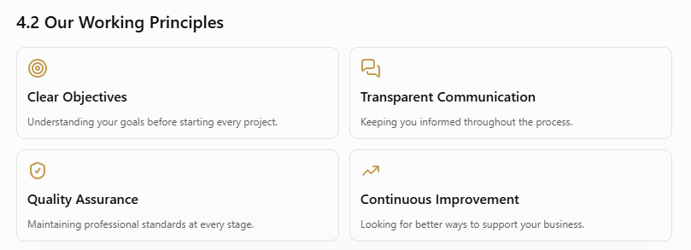
5. INDUSTRIES WE SERVICE

Empowering Businesses Across Diverse Industries.
At RHEK GLOBAL, we provide intelligent digital, marketing, sales, and outsourcing solutions to businesses across multiple industries. Our flexible services are designed to meet different business needs, improve operational efficiency, and support sustainable growth.

Cleaning & Janitorial
Real Estate & Property
Healthcare & Medical
E-commerce & Retail
Technology & IT
Hospitality & Tourism
Education & Training
Finance & Insurance
Logistics & Transportation
Fashion & Lifestyle
Startups & Small Businesses

Customized Solutions for Every Industry
Whatever your industry, RHEK GLOBAL is committed to understanding your business needs and delivering professional solutions aligned with your goals.

6. WHO WE ARE

RHEK GLOBAL – Your Trusted Partner in Business Growth.
Empowering Businesses Through Intelligent Digital, Operational & Outsourcing Solutions.
At RHEK GLOBAL, we are passionate about helping businesses grow, innovate, and succeed in an increasingly competitive world. We bring together digital expertise, creative solutions, strategic marketing, sales development, and professional outsourcing services under one platform.
Our goal is to simplify business operations, strengthen digital presence, create new opportunities, and deliver solutions that help businesses achieve sustainable growth.

6.1 Our Mission
Empowering Businesses. Enabling Growth.
Our mission is to provide innovative, reliable, and result-oriented business solutions that help organizations improve efficiency, expand their reach, and achieve their goals.

6.2 Our Vision
Building a Smarter Future for Businesses Worldwide.
Our vision is to become a globally recognized business solutions partner through innovation, professional excellence, and long-term client relationships.

6.3 Our Core Values
Integrity & Transparency
Building relationships through honesty, trust, and accountability.
Innovation & Creativity
Embracing modern ideas and technologies to deliver smarter solutions.
Quality & Excellence
Maintaining professional standards and consistent service quality.
Client-Centric Approach
Putting client requirements and business objectives first.
Continuous Growth
Improving our capabilities and creating long-term business value.

7. CLIENT TESTIMONIALS & CASE STUDIES
Do it by yourself
8. FAQ

How do I get started with RHEK GLOBAL?
Simply contact our team or book a meeting through our website. We will discuss your requirements, understand your goals, and recommend suitable solutions for your business.

Does RHEK GLOBAL offer a Money-Back Guarantee?
Yes. We offer a 100% Money-Back Guarantee for eligible services under our applicable refund policy. Our commitment is to provide professional service, transparency, and client satisfaction. Please review our official guarantee terms for eligibility and conditions.

9. 100% Money-Back Guarantee
Your Investment Protected. Your Satisfaction Guaranteed.
At RHEK GLOBAL, we believe in delivering value that meets your expectations. Our 100% Money-Back Guarantee reflects our commitment to service quality, transparency, and client satisfaction. We stand behind our work and take responsibility for delivering services according to mutually agreed project requirements and deliverables.
If our services fail to meet the agreed expectations, we are committed to reviewing your concerns and finding a fair resolution, including a full refund where eligible under our Money-Back Guarantee policy.

Our Commitment to You
- 100% Money-Back Protection: Eligible clients can request a full refund under our applicable guarantee terms.
- Quality Assurance: Professional service delivery with a focus on excellence.
- Complete Transparency: Clear agreements, expectations, and deliverables.
- Client-First Commitment: Your satisfaction remains our priority.
- Reliable Support: Dedicated assistance to address concerns and resolve issues.
RHEK GLOBAL – Your Trust, Our Commitment, Your Satisfaction.

11. Our Achievements & Statistics
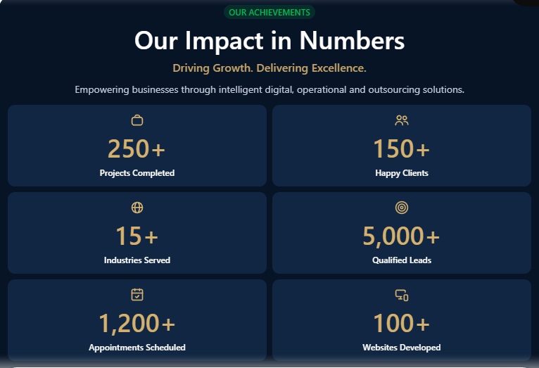

14. Final Call to Action (CTA)
Do it by yourself

10. Why Choose RHEK GLOBAL?
- One Partner, Multiple Business Solutions
- Customized Business Strategies
- Experienced Professional Team
- Quality-Focused Service Delivery
- Flexible & Scalable Solutions
- Long-Term Business Partnerships

13. Careers – Grow With Us
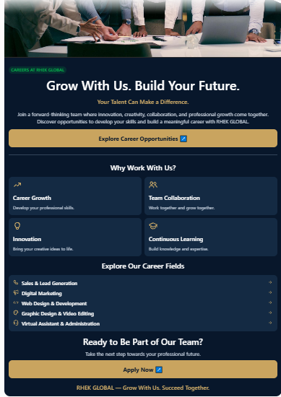

16. Newsletter Subscription
Do it by yourself

17. Footer Section
Do it by yourself

Get Exclusive Commercial Cleaning Leads – Pay Nothing Upfront!
We help commercial cleaning companies secure high-quality appointments with verified facility decision-makers, connecting them with businesses actively seeking trusted cleaning partners and long-term service solutions.

- Home
- About us
- Services
- Pricing
- Book a meeting
- Team
- Careers
- Contact

1. Company Profile
1.1 Business Information
• Company / Brand Name: RHEK GLOBAL
• Primary Headline / Value Proposition: Empowering businesses through intelligent digital, operational and outsourcing solutions.
Create few leads sample
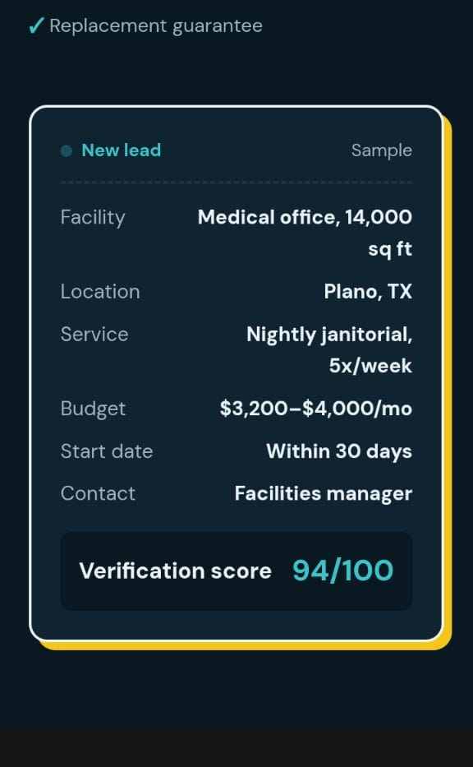
Verification score 94/100 nh diye just Verified likhley hobe
Verified
2. Services
Please go through the link below.

https://chatgpt.com/s/t_6ae6b249f950819194fe6a178649e256

3. Pricing

Please go through the link below.
https://chatgpt.com/s/t_6ae6c6ec04c8819180c93a3fc1c756b8
Pricing section create korar por nicher Div a ei rokom akta small offer make korben
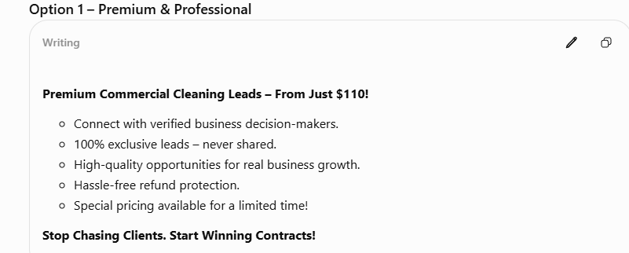
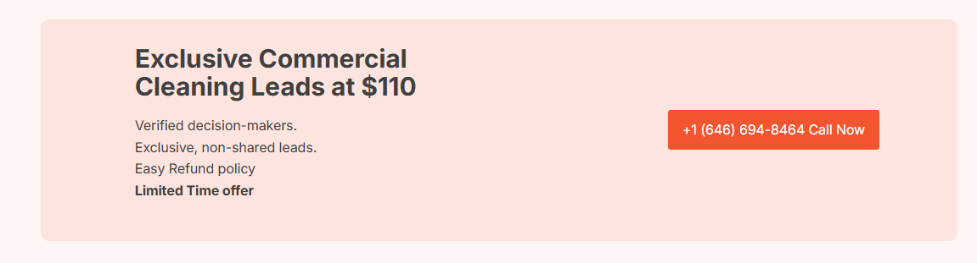
4. 100% Money-Back Guarantee
Your Investment Protected. Your Satisfaction Guaranteed.
At RHEK GLOBAL, we believe in delivering value that meets your expectations. Our 100% Money-Back Guarantee reflects our commitment to service quality, transparency, and client satisfaction. We stand behind our work and take responsibility for delivering services according to mutually agreed project requirements and deliverables.
If our services fail to meet the agreed expectations, we are committed to reviewing your concerns and finding a fair resolution, including a full refund where eligible under our Money-Back Guarantee policy.

Our Commitment to You
- 100% Money-Back Protection: Eligible clients can request a full refund under our applicable guarantee terms.
- Quality Assurance: Professional service delivery with a focus on excellence.
- Complete Transparency: Clear agreements, expectations, and deliverables.
- Client-First Commitment: Your satisfaction remains our priority.
- Reliable Support: Dedicated assistance to address concerns and resolve issues.
RHEK GLOBAL – Your Trust, Our Commitment, Your Satisfaction.

5. INDUSTRIES WE SERVICE

Empowering Businesses Across Diverse Industries.
At RHEK GLOBAL, we provide intelligent digital, marketing, sales, and outsourcing solutions to businesses across multiple industries. Our flexible services are designed to meet different business needs, improve operational efficiency, and support sustainable growth.

Real Estate & Property
Healthcare & Medical
E-commerce & Retail
Technology & IT
Hospitality & Tourism
Education & Training
Finance & Insurance
Logistics & Transportation
Fashion & Lifestyle
Startups & Small Businesses

Customized Solutions for Every Industry
Whatever your industry, RHEK GLOBAL is committed to understanding your business needs and delivering professional solutions aligned with your goals.

6. Why Choose RHEK GLOBAL?
Create it in a different way and use the different words .
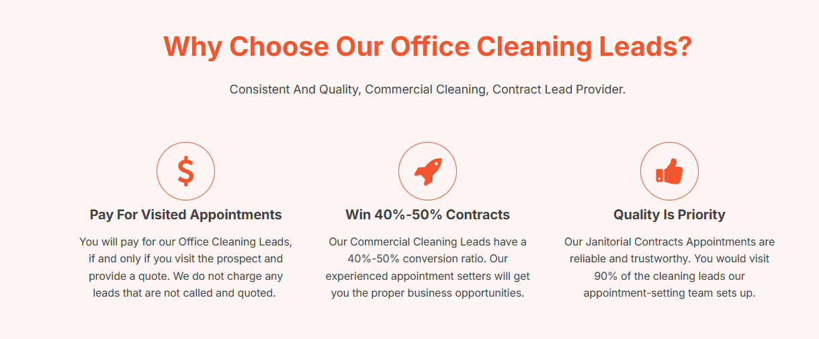

7. Our Achievements & Statistics

8. CLIENT TESTIMONIALS & CASE STUDIES
Do it by yourself

9. WHO WE ARE

RHEK GLOBAL – Your Trusted Partner in Business Growth.
Empowering Businesses Through Intelligent Digital, Operational & Outsourcing Solutions.
At RHEK GLOBAL, we are passionate about helping businesses grow, innovate, and succeed in an increasingly competitive world. We bring together digital expertise, creative solutions, strategic marketing, sales development, and professional outsourcing services under one platform.
Our goal is to simplify business operations, strengthen digital presence, create new opportunities, and deliver solutions that help businesses achieve sustainable growth.

6.1 Our Mission
Empowering Businesses. Enabling Growth.
Our mission is to provide innovative, reliable, and result-oriented business solutions that help organizations improve efficiency, expand their reach, and achieve their goals.

6.2 Our Vision
Building a Smarter Future for Businesses Worldwide.
Our vision is to become a globally recognized business solutions partner through innovation, professional excellence, and long-term client relationships.

6.3 Our Core Values
Integrity & Transparency
Building relationships through honesty, trust, and accountability.
Innovation & Creativity
Embracing modern ideas and technologies to deliver smarter solutions.
Quality & Excellence
Maintaining professional standards and consistent service quality.
Client-Centric Approach
Putting client requirements and business objectives first.
Continuous Growth
Improving our capabilities and creating long-term business value.

10. Final Call to Action (CTA)
Do it by yourself

11. Careers – Grow With Us

12. Newsletter Subscription
Do it by yourself

13. Footer Section
Do it by yourself

Do it by yourself
Do it by yourself
Do it by yourself
Do it by yourself
Do it by yourself
Do it by yourself
Please go through the link below.

https://chatgpt.com/s/t_6ae6a5b2ef84819183c9cbf38d779c52

